**SOFTWARE REQUIREMENT SPECIFICATION (SRS)**

**ON**

**LIBRARY MANAGEMENT SYSTEM**

**1.0 PROBLEM DEFINITION**

The library management system is software, which automates the job of a librarian.

1.1 The user can inquire about the availability of a book in which he can search by entering the author’s name or by entering the title of the book.

1.2 The user can borrow a book. He must provide the username and the card number, which is unique and confidential to each user. By confirming the authenticity of a user, the library management system provides information about the number of books already borrowed by the user and by referring to the database whether the user can borrow books or not. The library management system allows the user to enter the title and the author of the book and hence issues the book if it is available.

1.3 By entering the user details and the book details the user can return the borrowed book.

**2.0 SYSTEM REQUIREMENT SPECIFICATION**

**2.1 INTRODUCTION**

2.1.1 Purpose

2.1.1.1 The purpose of this SRS is to describe the requirements involved in developing a Library management system.

2.1.1.2 The intended audience is any person, who wants to inquire, borrow and return the books.

– 3 –

2.1.2 Scope

2.1.2.1 The product is titled Library Management System.

2.1.2.2 The product will perform the following tasks

2.1.2.2.1 Enquire about the availability of books.

2.1.2.2.2 Borrow books if available.

2.1.2.2.3 Return the borrowed books.

2.1.3 Definitions, Acronyms and Abbreviations

2.1.3.1 DBMS – Database Management System.

2.1.4 References

2.1.4.1 IEEE standard 830-1998 recommended practice for Software Requirements Specifications-Description.

2.1.5 Overview

2.1.5.1 The SRS contains an analysis of the requirements necessary to help easy design.

2.1.5.2 The overall description provides interface requirements for the Library Management System, product perspective, hardware interfaces, software interfaces, communication interface, memory constraints, product functions, user characteristics and other constraints.

2.1.5.3 Succeeding pages illustrate the characteristics of typical naïve users accessing the system along with legal and functional constraints enforced that affect Library Management System in any fashion.

– 4 –

**2.2 THE OVERALL DESCRIPTION**

2.2.1 Product perspective

2.2.1.1 Hardware interfaces

2.2.1.1.1 Hard disk: The database connectivity requires a hardware configuration that is on-line. This makes it necessary to have a fast database system running on high rpm hard disk permitting complete data redundancy and back-up systems to support the primary goal of reliability.

2.2.1.1.2 The system must interface with the standard output devise, keyboard and mouse to interact with this software.

2.2.1.2 Software interfaces

2.2.1.2.1 Back End: MS-Access 2007

2.2.1.2.2 Front End: Microsoft Visual Basic 6.0

2.2.1.3 Memory Constraints

2.2.1.3.1 No specific constraints on memory.

2.2.1.4 Operations

2.2.1.4.1 The software allows three modes of operations

2.2.1.4.1.1 Enquire about the availability and status of books.

2.2.1.4.1.2 By extracting the username and password the software allows the user to borrow a maximum of three books.

2.2.1.4.1.3 By extracting the username and password the software

allows the user to return the borrowed books.

2.2.2 Product Functions

2.2.2.1.1 Enquire about the availability and status of books.

2.2.2.1.2 Search the availability of book by entering the title of the book.

2.2.2.1.3 Search the availability of book by entering the author of the book.

2.2.2.1.4 The software validates the authentic user by extracting their user name and password.

2.2.2.1.5 After the validation of the user software allows the user to borrow a maximum of three books based on the number of books which where already borrowed.

2.2.2.1.6 After the validation of the user software allows the user to return the

books, which where borrowed.

– 5 –

2.2.3 User characteristics

2.2.3.1 The intended users of this software need not have specific knowledge as to what is the internal operation of the system. Thus the end user is at a high level of abstraction that allows easier, faster operation and reduces the knowledge requirement of end user

2.2.3.2 The Product is absolutely user friendly, so the intended users can be the naïve users.

2.2.3.3 The product does not expect the user to possess any technical background. Any person who knows to use the mouse and the keyboard can successfully use this product.

2.2.4 Constraints

2.2.4.1 The user has a unique username and password, there are no options to retrieve a password or username in case it is forgotten or lost hence the user is requited to remember or store the username and password.

**2.3 SPECIFIC REQUIREMENTS**

2.3.1 Logical Database Requirements

2.3.1.1 The system should contain databases that include all necessary information for the product to function according to the requirements. These include relations such as user details and book details.

2.3.1.2 The user details refer to the information such as name, card number, no. of books borrowed, the title and the name of the author of the books that were borrowed.

2.3.1.3 The book details refer to the information such as the title of the book, author availability status and the number of copies that is available.

– 6 –

**2.4 FRONT – END DESCRIPTION**

The library management system is automated library system where the user can search for the book by either entering the details of the book or the author’s name. By entering the username and the password the software, by checking the number of books that are already borrowed enables us to borrow a maximum of three books. And by entering the username and password (card number), which is unique, the user can return the books.

**2.5 BACK – END DESCRIPTION**

The library management system consists of two tables. One contains the student details such as the name, card number that is the password, title and the author of the three books, which could be borrowed. The book details consist of the title of the book, number of copies, author and the availability status.

**2.6 DATA STRUCTURES**

2.6.1. BOOK DETAILS

|  |  |  |
| --- | --- | --- |
| **FIELD NAME** | **TYPE** | **CONSTRAINTS** |
| REGISTER_NO | NUMBER | NOT NULL |
| BOOK_ID | NUMBER | NOT NULL |
| ISSUE_DATE | DATE/TIME |  |
| RETURN_DATE | DATE/TIME |  |
| BOOK_NAME | TEXT |  |
| 2.6.2. STUDENT DETAILS |  |  |
| **FIELD NAME** | **TYPE** | **CONSTRAINTS** |
| REGISTER_NO | NUMBER | NOT NULL |
| FNAME | TEXT | NOT NULL |
| LNAME | TEXT |  |
| GENDER | TEXT |  |
| DEPT | TEXT |  |
| EMAIL | TEXT |  |
| PASSWORD | TEXT |  |
| NO_OF_BOOKS | NUMBER |  |

– 7 –

**2.7 DATA FLOW DIAGRAM**

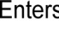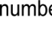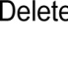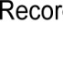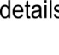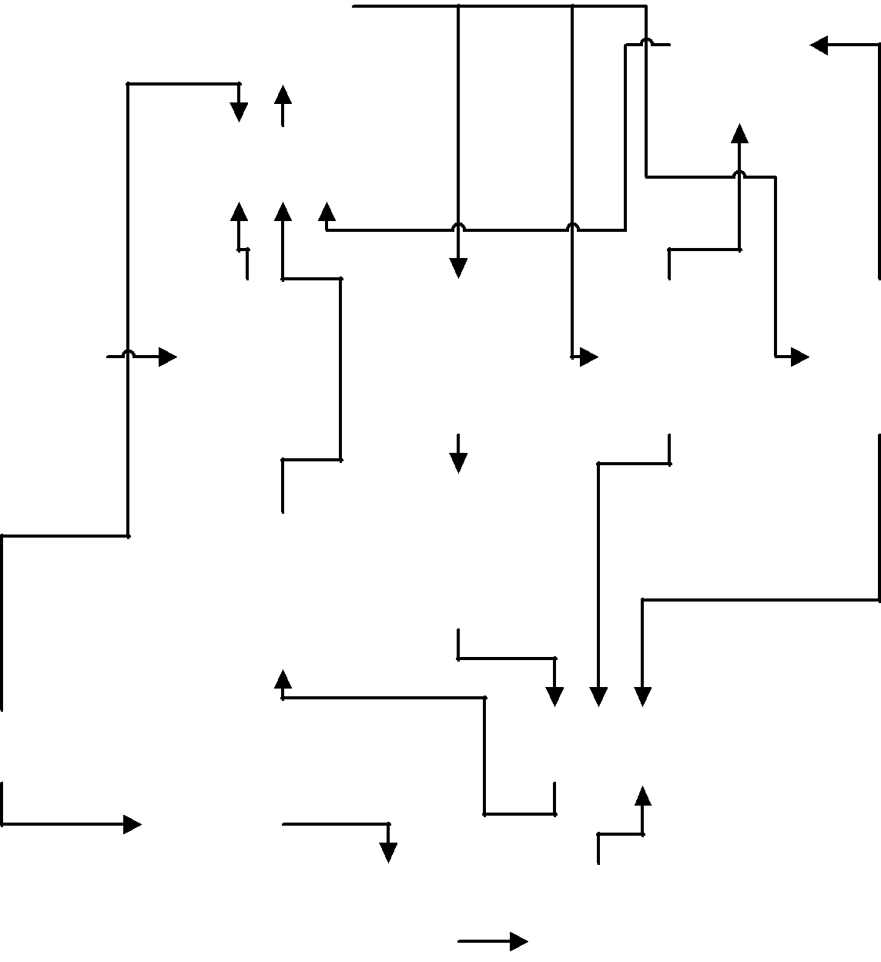

– 8 –

**3.0 TESTING:**

|  |  |  |  |  |
| --- | --- | --- | --- | --- |
| **FORM NAME** | **INPUT** | **EXPECTED** | **ACTUAL** | **STATUS** |
|  |  | **OUTPUT** | **OUTPUT** |  |
|  |  |  |  |  |
| **MAIN MENU** | Menu Option | Show required | Required | Pass |
| **FORM** |  | Form | Form was |  |
|  |  |  | displayed |  |
|  |  |  |  |  |
| **MEMBERSHIP** | Member | Create new | New Account | Pass |
| **FORM** | details are | member | was created |  |
|  | entered | account |  |  |
|  |  |  |  |  |
| **LOGIN FORM** | Member ID | If password is | Member | Pass |
|  | and password | correct, login. | authenticated |  |
|  |  |  | for future |  |
|  |  |  | operations. |  |
|  |  |  |  |  |
| **ISSUE FORM** | Book ID | If books issued | Book issued | Pass |
|  |  | is less than |  |  |
|  |  | three, issue the |  |  |
|  |  | book. |  |  |
|  |  |  |  |  |
| **RETURN/REISSUE** | Book ID | Book returned/ | Book returned/ | Pass |
| **FORM** |  | reissued | reissued |  |
|  |  |  |  |  |
| **BOOK ENQUIRY** | Book Name | Book details | Book details | Pass |
|  |  | are displayed | are displayed |  |
|  |  |  |  |  |

– 9 –

**4.0 SAMPLE FORMS**

MAIN MENU FORM

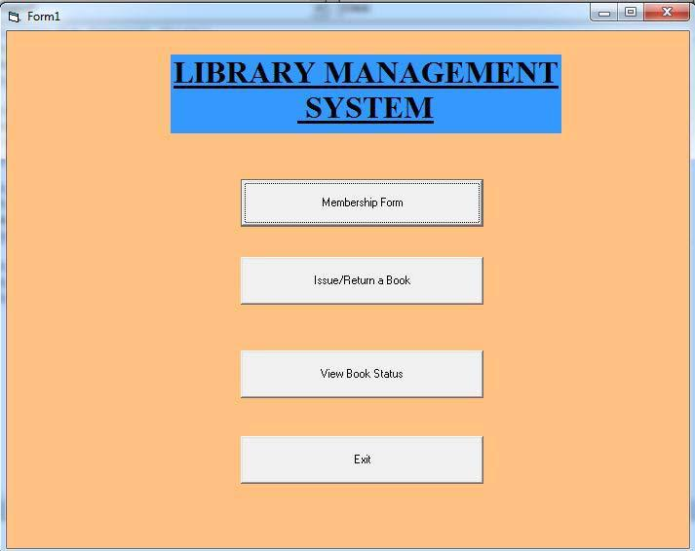

– 10 –

MEMBERSHIP FORM

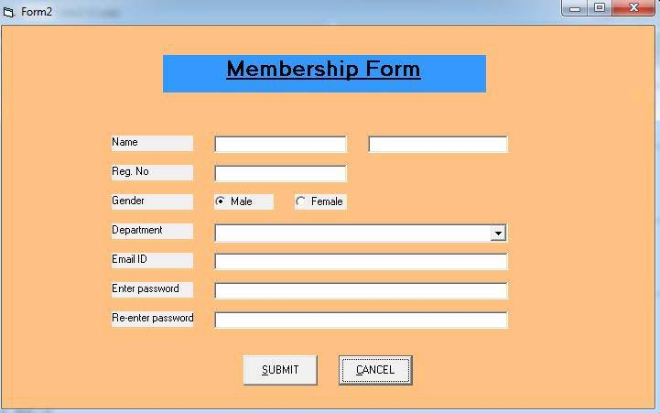

LOGIN FORM

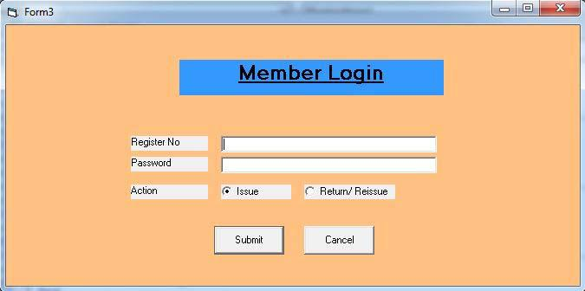

– 11 –

ISSUE FORM

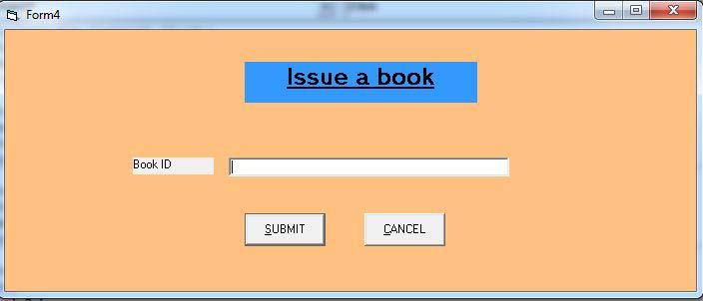

RETURN/REISSUE FORM

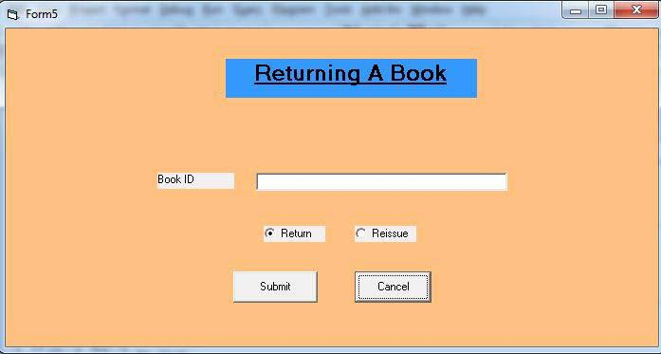

– 12 –

BOOK ENQUIRY FORM

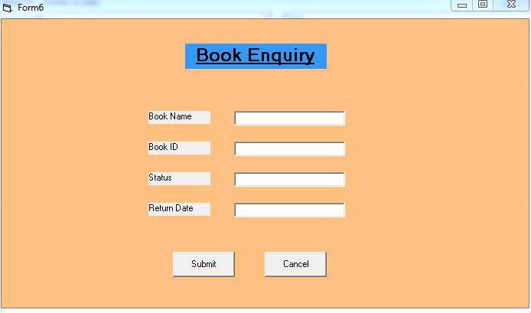

**4.0 RESULT:**

**Thus the online Library System was implemented using the specified front end and back end tools.**